
 |  |  |  |  | 71755 |  | 1.261.267,09 €
Category | Immage | Reference | EAN | Description | Quantity | Price List € |  | Pcs per carton | Pcs per pallet
Household |  | BIA6-0A3PT024 | 8002617956994 | PETRAVERA DONATELLO - PENTOLA CM.24 | 144 | 32,21 € | 4.637,52 € | 4 | 80
Household |  | BIA6-0A8PA020 | 8002617942904 | LINEA WHITE - PADELLA PER COTTURA A INDUZIONE CM.20 | 180 | 20,81 € | 3.744,90 € | 4 | 288
Household |  | BIA6-0A8PA028 | 8002617942966 | LINEA WHITE - PADELLA PER COTTURA A INDUZIONE CM.28 | 388 | 34,11 € | 13.232,74 € | 4 | 112
Household |  | BIA6-0GCC2020 | 8002617948807 | LINEA SAHARA PETRABLANCA - CASSERUOLA 2 MANICI 20 | 752 | 31,26 € | 23.503,76 € | 4 | 180
Household |  | BIA6-0GCC2024 | 8002617948814 | LINEA SAHARA PETRABLANCA - CASSERUOLA 2 MANICI 24 | 284 | 35,06 € | 9.955,62 € | 4 | 128
Household |  | BIA6-0GCTE024 | 8002617948821 | SAHARA - TEGAME 24 | 216 | 34,11 € | 7.366,68 € | 4 | 160
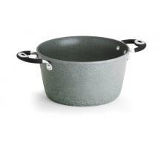
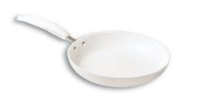
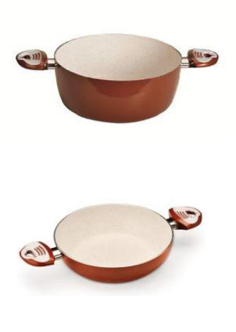
Household |  | BIA6-0GFCPN14 | 8002617011198 | FIESTA GRANDE - COPERCHIO UNIVERSALE 14 | 906 | 4,66 € | 4.217,43 € | 12 | 840
Household |  | BIA6-0GFCPN30 | 8002617011273 | FIESTA GRANDE - COPERCHIO UNIVERSALE 30 | 510 | 6,56 € | 3.343,05 € | 12 | 288
Household |  | BIA6-0GWC2020 | 8002617948647 | LINEA HIMALAYA PETRABLANCA - CASSERUOLA 2 MANICI 20 | 1904 | 32,21 € | 61.318,32 € | 4 | 160
Household |  | BIA6-0GWSP028 | 8002617948623 | LINEA HIMALAYA PETRABLANCA - SALTAPASTA 28 | 114 | 30,31 € | 3.454,77 € | 6 | 288
Household |  | BIA6-0GWTE028 | 8002617948678 | LINEA HIMALAYA PETRABLANCA - TEGAME 28 | 148 | 34,11 € | 5.047,54 € | 4 | 132
Household |  | BIA6-Y0ABCV0160 | 8002617813679 | LINEA ESSENZA - COPERCHIO VETRO CM.16 | 810 | 4,66 € | 3.770,55 € | 6 | 432
Household |  | BIA6-Y0ABCV0180 | 8002617813709 | LINEA ESSENZA - COPERCHIO VETRO CM.18 | 186 | 5,61 € | 1.042,53 € | 6 | 324
Household |  | BIA6-Y0BCC20160 | 8002617876353 | LINEA CHIC AETERNUM CASSERUOLA 2 MANICI CM.16 | 294 | 14,73 € | 4.329,15 € | 6 | 324
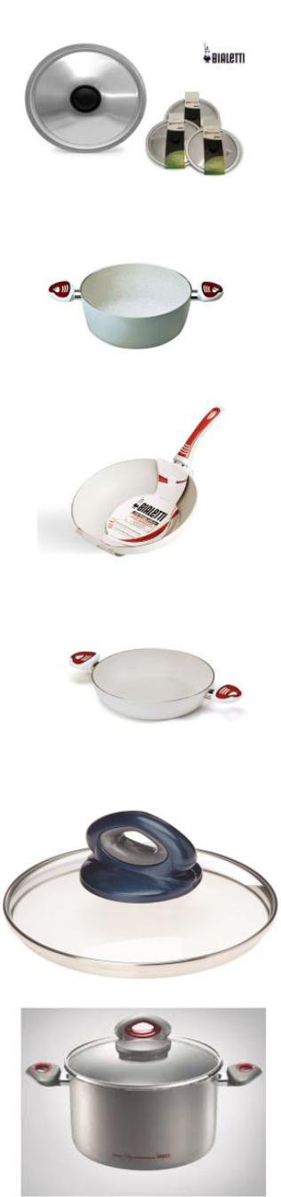
Household |  | BIA6-Y0CBCV0240 | 8002617925587 | LINEA CERAMICA OK COPERCHIO CM 24 | 288 | 7,32 € | 2.106,72 € | 6 | 378
Household |  | BIA6-Y0CMT20240 | 8002617937924 | LINEA BLACK STONE TEGAME 2 MANICI 24 cm | 3762 | 24,61 € | 92.564,01 € | 6 | 168
Household |  | BIA6-J0CEPA0240 | 8002617922234 | LINEA CERAMICA BLACK STONE PADELLA CM.24 | 340 | 23,65 € | 8.041,00 € | 4 | 104
Household |  | BIA6-Y0CWC10160 | 8002617929615 | LINEA CERAMICA BROWN INDUCTION CASSERUOLA 16 | 1632 | 17,81 € | 29.070,00 € | 6 | 288
Household |  | BIA6-Y0CWC20200 | 8002617929660 | LINEA CERAMICA BROWN INDUCTION CASSERUOLA 2 MANICI 20 | 102 | 23,37 € | 2.383,74 € | 6 | 150
Household |  | BIA6-Y0CWC20240 | 8002617929714 | LINEA CERAMICA BROWN INDUCTION CASSERUOLA 2 MANICI 24 | 1356 | 30,97 € | 41.995,32 € | 6 | 96
Household |  | BIA6-Y0CWCV0160 | 8002617930291 | LINEA CERAMICA BROWN COPERCHIO 16 CM | 726 | 4,70 € | 3.414,02 € | 6 | 756
Household |  | BIA6-Y0CWPA0200 | 8002617929882 | LINEA CERAMICA BROWN INDUCTION PADELLA 20 CM | 1314 | 17,58 € | 23.093,55 € | 6 | 240
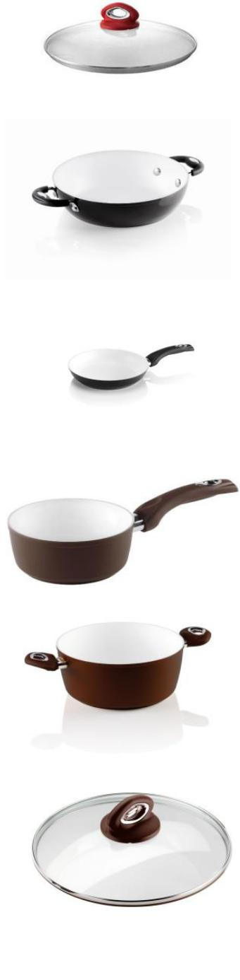
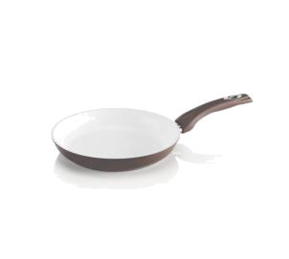  Household |  | BIA6-Y0CWPA0220 | 8002617929936 | LINEA CERAMICA BROWN INDUCTION PADELLA 22 CM | 2238 | 19,71 € | 44.116,58 € | 6 | 264
Household |  | BIA6-Y0CWPA0240 | 8002617929967 | LINEA CERAMICA BROWN INDUCTION PADELLA 24 CM | 198 | 22,61 € | 4.476,78 € | 6 | 144
Household |  | BIA6-Y0CWPA0260 | 8002617929998 | LINEA CERAMICA BROWN INDUCTION PADELLA 26 CM | 2340 | 24,23 € | 56.686,50 € | 6 | 144
Household |  | BIA6-Y0CWPA0280 | 8002617930048 | LINEA CERAMICA BROWN INDUCTION PADELLA 28 CM | 1482 | 30,88 € | 45.756,75 € | 6 | 120
Household |  | BIA6-Y0CWPA0300 | 8002617930079 | LINEA CERAMICA BROWN INDUCTION PADELLA 30 CM | 1554 | 31,35 € | 48.717,90 € | 6 | 96
Household |  | BIA6-Y0CWPT0200 | 8002617930444 | LINEA CERAMICA BROWN INDUCTION PENTOLA 20 CM | 462 | 25,37 € | 11.718,63 € | 6 | 120
Household |  | BIA6-Y0CWPT0240 | 8002617930475 | LINEA CERAMICA BROWN INDUCTION PENTOLA 24 CM | 54 | 32,78 € | 1.769,85 € | 6 | 72
Household |  | BIA6-Y0CWSET002 | 8002617944892 | LINEA CERAMICA BROWN FRYPAN 24+28 CM | 2334 | 48,93 € | 114.190,95 € | 4 | 48
Household |  | BIA6-Y0CWSP0280 | 8002617930208 | LINEA CERAMICA BROWN INDUCTION SALT.28 CM | 1188 | 29,93 € | 35.550,90 € | 6 | 120
Household |  | BIA6-Y0CWT20240 | 8002617930239 | LINEA CERAMICA BROWN INDUCTION TEGAME 24 2 M | 3054 | 23,66 € | 72.242,37 € | 6 | 144
Household |  | BIA6-Y0CWT20280 | 8002617930260 | LINEA CERAMICA BROWN INDUCTION TEGAME 28 2 M | 108 | 31,26 € | 3.375,54 € | 6 | 96
Household |  | BIA6-0GGAC002 | 8002617895217 | TOOLS GENIUS - SCHIUMAROLA INOX | 114 | 9,41 € | 1.072,17 € | 6 | 404
Household |  | BIA6-0GGAC007 | 8002617895330 | TOOLS GENIUS - SCHIACCIAPATATE INOX | 1044 | 8,46 € | 8.827,02 € | 6 | 1950
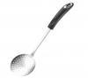
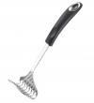
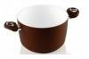
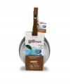

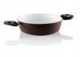
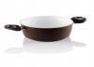
Household |  | BIA6-0GGAC022 | 8002617895781 | TOOLS GENIUS - PALETTA GELATO INOX | 522 | 5,61 € | 2.925,81 € | 6 | 4320
Household |  | BIA6-0GGAC024 | 8002617895842 | TOOLS GENIUS - SCAVINO INOX | 1620 | 4,66 € | 7.541,10 € | 6 | 5670
Household |  | BIA6-0GGAC025 | 8002617895873 | TOOLS GENIUS - LEVATORSOLI | 1128 | 3,71 € | 4.179,24 € | 6 | 5832
Household |  | BIA6-ZDCACMAT06 | 8002617953443 | D&C - MATTARELLO CUORI TRASPARENTE | 2022 | 15,11 € | 30.542,31 € | 6 | 1728
Household |  | BIA6-ZDCACMAT07 | 8002617953450 | D&C - MATTARELLO FIORI TRASPARENTE | 1938 | 15,11 € | 29.273,49 € | 6 | 1620
Household |  | BIA6-ZDCACMAT08 | 8002617953467 | D&C - MATTARELLO RIGHE TRASPARENTE | 2304 | 15,11 € | 34.801,92 € | 6 | 1620
Household |  | BIA6-ZDCACMAT09 | 8002617953474 | D&C - MATTARELLO QUADRATI TRASPARENTE | 2358 | 15,11 € | 35.617,59 € | 6 | 1728
Household |  | BIA6-ZDCACSTA01 | 8002617953627 | D&C - STAMPINI IN PLASTICA CUCCHIAINI | 954 | 8,46 € | 8.066,07 € | 6 | 972
Household |  | BIA6-ZDCSICC005 | 8002617951869 | D&C - STAMPO CIOCC. CUPOLE | 3132 | 3,71 € | 11.604,06 € | 6 | 1482
Household |  | BIA6-ZDCSICC006 | 8002617951845 | D&C - STAMPO CIOCC. NODI | 3234 | 3,71 € | 11.981,97 € | 6 | 3414
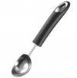
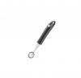
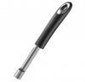
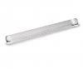
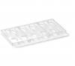
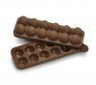
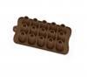
Household |  | BIA2-0DSCU001 | 8002617859837 | LINEA DOLCE E SALATO SET CUORI | 434 | 5,10 € | 2.213,40 € | 10 | 1350
Household |  | BIA2-0DSBU022 | 8002617859981 | DOLCE SALATO BUDINO 22 CM | 102 | 9,70 € | 989,40 € | 6 | 420
Household |  | BIA-Y0FCCV0240 | 8002617949224 |  | 2200 | 6,27 € | 13.794,00 € | 6 | 378
Household |  | BIA-Y0FCCV0280 | 8002617949231 | FUSIONE COLOR - COPERCHIO 28 | 900 | 6,84 € | 6.156,00 € | 6 | 288
Household |  | BIA6-00AGD474-01 | 8002617955652 | EXPO MINI SUMMER PADELLINA VIOLA 16cm | 2100 | 6,60 € | 13.860,00 €
Household |  | BIA6-00AGD474-02 | 8002617955645 | EXPO MINI SUMMER PADELLINA VERDE 16cm | 2100 | 6,60 € | 13.860,00 €
Household |  | BIA6-00AGD475-01 | 8002617955676 | EXPO MINI SUMMER CASSERUOLA VIOLA 14cm | 948 | 11,63 € | 11.025,24 €
Household |  | BIA6-00AGD475-02 | 8002617955669 | EXPO MINI SUMMER CASSERUOLA VERDE 14cm | 948 | 11,63 € | 11.025,24 €
Household |  | BIA2-0TRTR024 | 8002617945332 | TRUDI EVOLUTION TOR.C/ASOLA 24 | 1632 | 15,50 € | 25.296,00 € | 6 | 324
Household |  | BIA2-0TRTR028 | 8002617945356 | TRUDI EVOLUTION TOR.C/ASOLA 28 | 522 | 18,90 € | 9.865,80 € | 6 | 276
Household |  | BIA2-0TRTR032 | 8002617945370 | TRUDI EVOLUTION TOR.C/ASOLA 32 | 1140 | 21,90 € | 24.966,00 € | 6 | 144
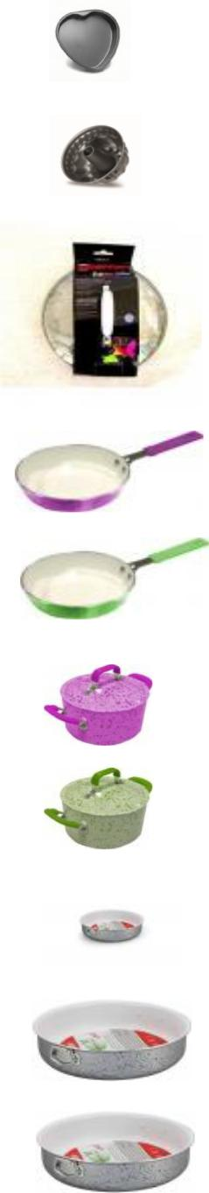
Household |  | BIA2-0LEC1A14 | 8002617825665 | LEONARDO CASSERUOLA 1M CM14 | 570 | 21,50 € | 12.255,00 € | 6 | 540
Household |  | BIA2-0TRCB016 | 8002617945981 | TRUDI EVOLUTION COP.BON.16 | 227 | 6,20 € | 1.407,40 € | 6 | 648
Household |  | BIA2-0TRCB018 | 8002617946001 | TRUDI EVOLUTION COP.BON.18 | 54 | 6,80 € | 367,20 € | 6 | 216
Household |  | BIA2-0TRCB020 | 8002617946025 | TRUDI EVOLUTION COP.BON.20 | 168 | 7,20 € | 1.209,60 € | 6 | 276
Household |  | BIA2-0TRCB028 | 8002617946087 | TRUDI EVOLUTION COP.BON.28 | 672 | 10,20 € | 6.854,40 € | 6 | 216
Household |  | BIA3-0002153 | 8006363021531 | NUOVA DAMA MOKA 6TZ | 311 | 39,90 € | 12.408,90 € | 0 | 0
Household |  | BIA3-0002160 |  | CIOCCOLATIERA S/BASE TIMER | 3614 | 21,90 € | 79.146,60 € | 0 | 0
Household |  | BIA3-0003742 | 8006363037426 | MOKA COLOUR 3TZ BIANCO | 90 | 25,90 € | 2.331,00 € | 0 | 0
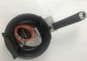
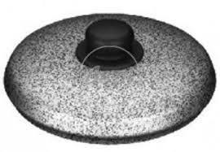
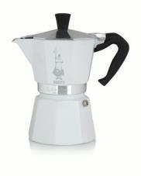
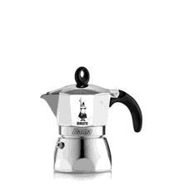
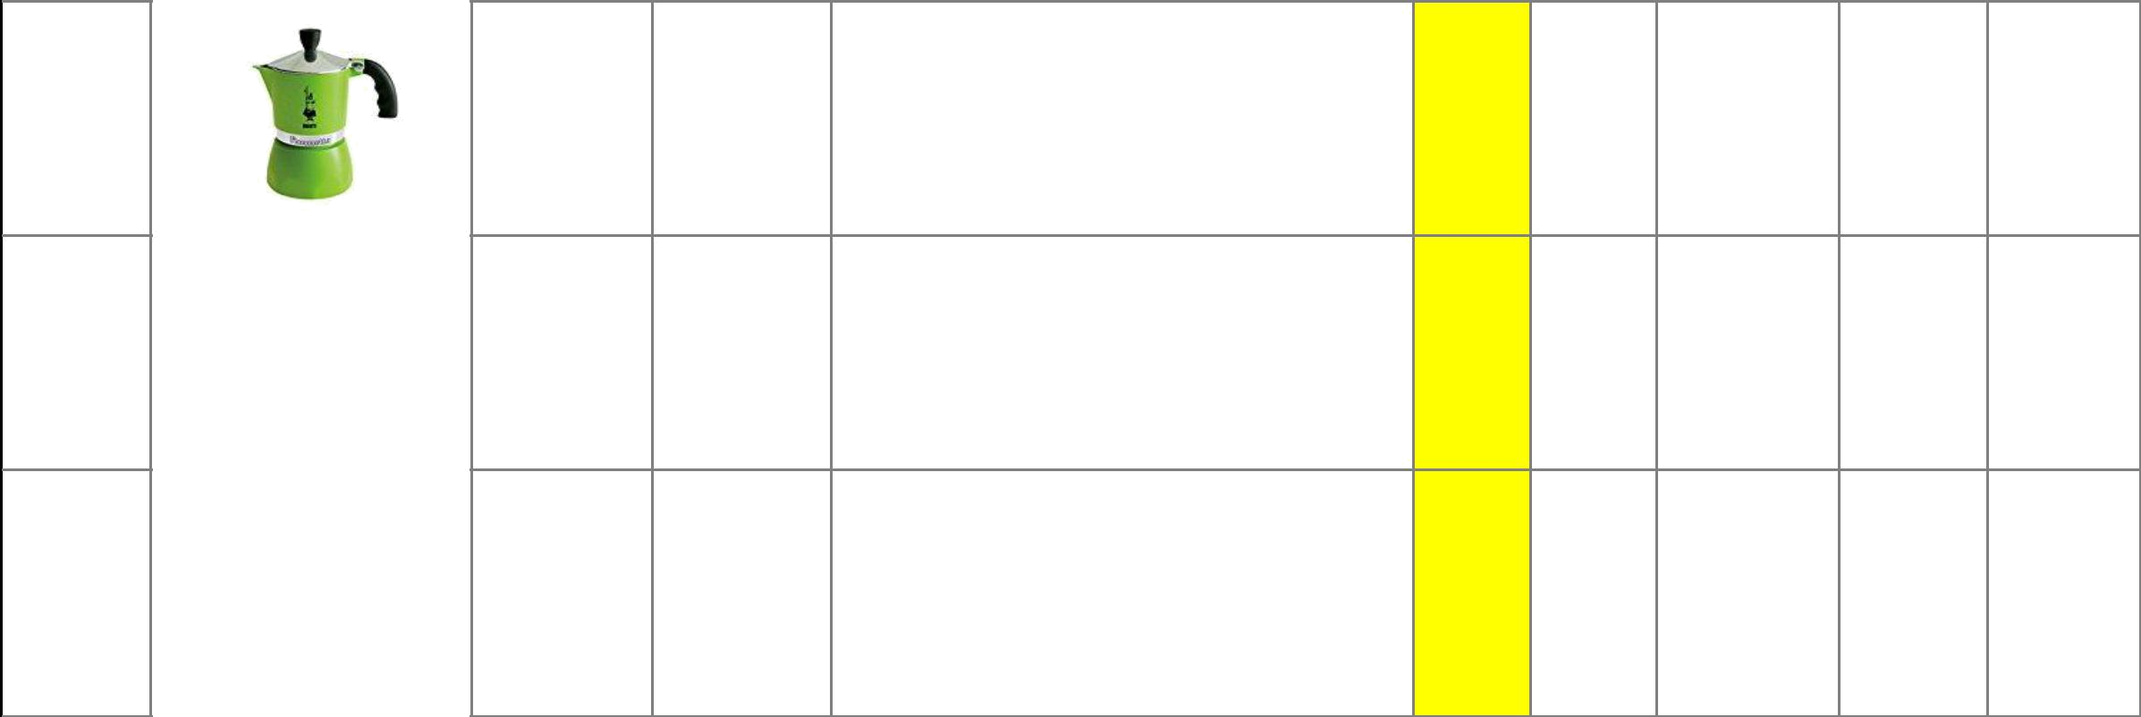  Household | BIA3-0003962 | 8006363039628 | CAFFETT.FIAMMETTA 3TZ VERDE | 491 | 25,90 € | 12.716,90 € | 0 | 0

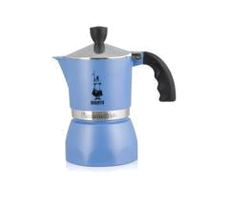

Household | BIA3-0003972 | 8006363039727 | CAFFETT.FIAMMETTA 3TZ AZZURRO | 540 | 25,90 € | 13.986,00 € | 0 | 0

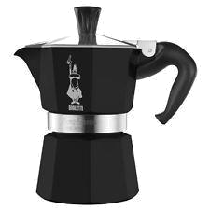

Household | BIA3-0004182 | 8006363998048 | MOKA EXPRESS BLACK 3TZ | 254 | 34,90 € | 8.864,60 € | 0 | 0

